**DIGITAL PORTFOLIO**

**STUDENT NAME: LOGAKISHORE M**

**REGISTER NO:** 2426J0488

**NMID: 3303F9C5EEEF8698E534447F5CD2FC2D**

**DEPARTMENT:** Information Technology

**COLLEGE:** Sri Krishna Adithya College of Arts and Science /

Bharathiyar University

|  |
| --- |
| **AGENDA**  1.Problem Statement  2.Project Overview  3.End Users  4.Tools and Technologies  5.Portfolio design and Layout  6.Features and Functionality  7.Results and Screenshots  8.Conclusion  9.Github Link |

# PROBLEM STATEMENT

# Difficulty in showcasing homemade accessories in an interactive way.

# Users face challenges in selecting and tracking multiple items online.

# Lack of a dynamic system to update and display chosen accessories in real time.

# Need for a simple, responsive, and user-friendly interface for selection.

# Requirement for easy contact details of the creator for inquiries and purchases.

# PROJECT OVERVIEW

* **Clean UI – The design is neat, centered, and easy to understand with good use of colors and spacing.**
* **Interactive Selection – Accessories can be selected/deselected dynamically with clear visual feedback.**

* **Good Styling Practices – Consistent font, hover effects, rounded corners, and shadows make it look polished.**
* **User-Friendly Contact Section – Provides clear contact details with a clickable email link.**
* **Responsive Layout – Flexbox usage helps maintain alignment and adapts reasonably for different screen sizes.**
* **Code Readability – CSS classes and JS function are simple and easy to follow.**

**WHO ARE THE END USERS?**

* General Customers / Shoppers – People who want to browse and select handmade accessories online before purchase.
* Students & Hobbyists – Learners exploring small projects on web development and interactive selection systems.
* Homemade Product Sellers – Small business owners who can use such a system to showcase their handmade items.
* Event / Craft Fair Organizers – To provide a digital catalog for visitors to pick items of interest.
* Gift Buyers – Individuals searching for unique, personalized, or handcrafted gifts.HTML5 – for structuring the portfolio and movie review pages.

**TOOLS AND TECHNOLOGIES**:

* HTML5 – For structuring the web page and content (titles, sections, items, contact info).
* CSS3 – For styling, layout design, colours, hover effects, and responsive alignment using Flexbox.
* JavaScript (Vanilla JS) – For interactivity, toggling selection of items, and dynamically updating selected accessories.
* Web Browser – (e.g., Chrome, Edge, Firefox) to run and test the project.
* Code Editor – (e.g., VS Code, Sublime Text, Notepad++) for writing and editing the code.

## POTFOLIO DESIGN AND LAYOUT

* Layout Design:

Two main sections: Accessory Selection Card and Contact Card.

* Colour Palette:

Brown/Beige tones (#8b4513, #ffe4c4, #ffdab9) to reflect the natural, handmade, and earthy feel of accessories.

* Typography Arial Sans-serif for clean readability

Headings use warm colors for emphasis.

* Interactivity

Hover effects (scale(1.05) + color change) make items feel clickable.

JavaScript toggle selection adds/removes highlight and updates selected list dynamically.

* Contact Section

Clean card-style design.

# FEATURES AND FUNCTIONALITY

**FUNCTIONS:**

* Interactive Accessory Selection – Users can click on items to select/deselect them.
* Real-Time Display – Selected items are instantly shown in the “Selected” section.
* Attractive Styling – Hover effects, scaling animation, shadows, and rounded corners.
* Contact Section – Provides creator’s name and clickable email link.
* Responsive Design – Uses Flexbox for alignment and adjusts well across screen sizes.
* Custom Highlighting – Selected items get a unique style (.selected with dark background and white text).

**FUNCTIONALITY**

* Item Selection/Deselection:

Clicking an accessory highlights it and adds it to the selected list.

Clicking again removes it from the selection.

* Dynamic Selection List:

Updates the text dynamically to show all chosen items.

Displays “Selected: None” if no items are chosen.

* Interactive Hover Effect:

When hovering over an item, its background changes and it slightly enlarges.

* Contact Option:

Users can directly click the email link to contact the creator.

* JavaScript Control:

Uses an array (selected[]) to store chosen items.

Updates UI dynamically with toggle Selection() function

## RESULTS AND SCREENSHOTS

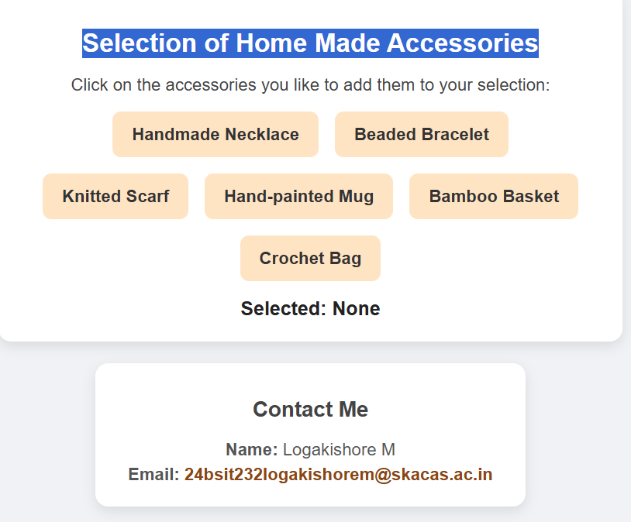

**SELECTION MODE SECTION**

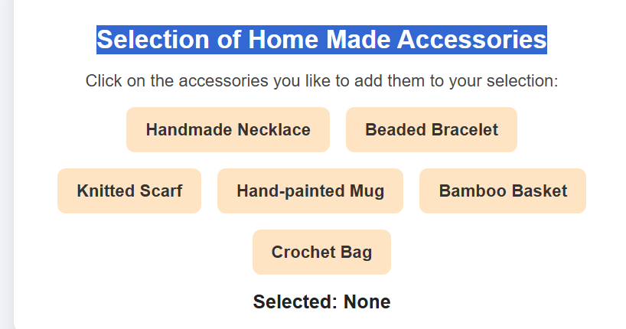

**SELECTED SECTION:**

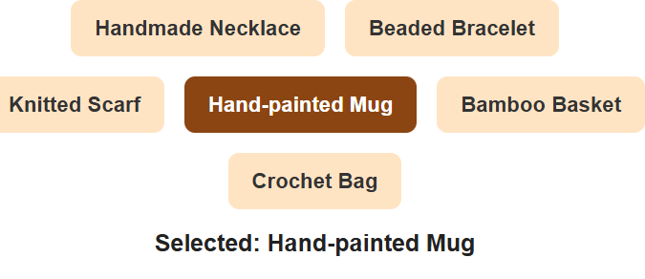

### ➢

**CONTACT SECTION:**

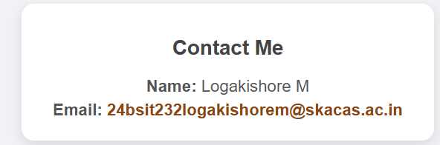

**SKILLS SECTION**

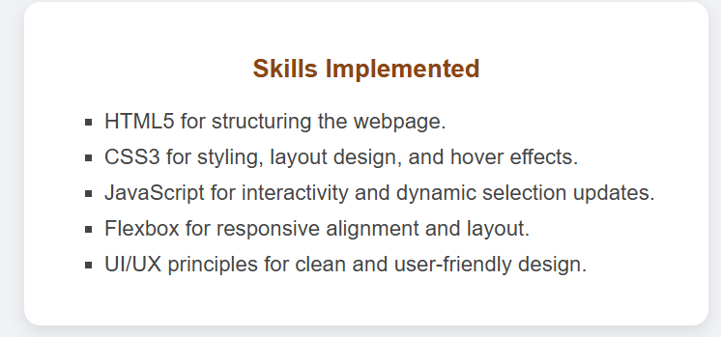

# CONCLUSION

The project “Selection of Home Made Accessories” successfully demonstrates the use of HTML, CSS, and JavaScript to create an interactive and user-friendly web application. It allows users to select their preferred handmade accessories, view their choices in real-time, and access the creator’s contact details seamlessly. The clean design, responsive layout, and simple functionality make it a practical mini-project that reflects core web development skills while also highlighting the potential for use in small business or e-commerce platforms.

## GITHUB LINK

## https://github.com/logakishore3012/TNSDC_FWD_DIGITAL_PORTFOLIO.git